Case Study: Creating and Using Simple Delegates
To use delegates in our application, we perform the following three steps:
- Declare the delegate type
- Create a delegate object, and bind it to a particular method
- Invoke the method by using the delegate object
We'll show an example of how to declare a delegate to draw different types of shape on a Windows form.
The form will have the following appearance:
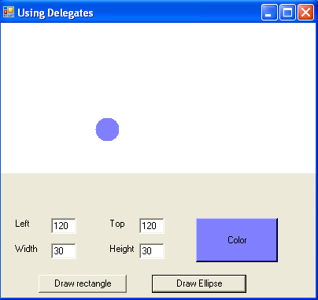
When the user clicks the Draw rectangle button, the application displays a rectangle with the specified position, size, and color. Likewise, when the user clicks the Draw ellipse button, the application displays an ellipse with the specified characteristics.
To achieve this functionality, we could write two completely separate button-click event handler methods to handle the Draw rectangle and Draw ellipse click events. However, this would result in a great deal of duplicate code, as both methods would need to perform the following tasks:
- Make sure all the textboxes have been filled in, to specify the position and size of the shape
- Make sure the shape fits in the drawing area on the screen
- Create a brush with the specified color
- Draw the required shape
To avoid duplication of code, we'll use a delegate to represent the drawing operation required. The delegate will either point to the FillRectangle () method or the FillEllipse () method, both of which are defined in the Graphics class in the .NET Framework class library. Then we'll write a generic method that takes this delegate as a parameter, and uses the delegate to invoke the appropriate drawing operation.
/* ----------------------------------------------------------------------
Define a Delegate type, to indicate signature of method to call
----------------------------------------------------------------------*/
delegate void DrawShape(Brush aBrush, Rectangle aRect);

public partial class UsingDelegates : Form
{

/*----------------------------------------------------------------
Declare a Rectangle field, to indicate available drawing area
----------------------------------------------------------------*/
private Rectangle mRect;

/* ----------------------------------------------------------------
When the form receives a paint event, color the available drawing area white
----------------------------------------------------------------*/
private void UsingDelegates_Paint(object sender, PaintEventArgs e)
{
mRect = new Rectangle(0, 0, Width, Height / 2);
e.Graphics.FillRectangle(new SolidBrush(Color.White), mRect);
}

private void btnColor_Click(object sender, System.EventArgs e)
{
ColorDialog dlgColor = new ColorDialog();
dlgColor.ShowDialog(this);
btnColor.BackColor = dlgColor.Color;

}
}
Note the following points in this code:
- We declare a private field named mRect to represent the drawing area on the form.
- We initialize the mRect field whenever the form paints itself, and paint the rectangle white.
- We've provided a click-event handler method for the Color button on our form. The method displays the standard color dialog box, so the user can choose a color for the next shape. To indicate which color has been selected, we repaint the Color button using the selected color. Note that it is not the name of the method that specifies that it handles the Click event from btnColor. The wiring of methods and events is done in the omitted Forms Designer code.
Now let's start looking at the delegate-specific code. Just before the start of the class definition, we placed a delegate definition. It looks like this:
/* ----------------------------------------------------------------------
Define a Delegate type, to indicate signature of method to call
----------------------------------------------------------------------*/
delegate void DrawShape(Brush aBrush, Rectangle aRect);

The delegate definition is like a class definition: it specifies a new type. It is a not part of the UsingDelegates class, but forms an independent class of its own. This delegate represents methods that return void and take two parameters:
- A Brush object, to specify the color of the shape
- A Rectangle object, to specify the position and size of the shape
This delegate corresponds with the signatures of the FillRectangle () and FillEllipse () methods in the Graphics class. The next step is to create an instance of the type, and bind it to a specific method on a particular object. Here is an example showing how to create a DrawShape instance and bind it to the FillRectangle () method on a Graphics object:
/* ----------------------------------------------------------------
Handle the Click event for the btnDrawRect button
----------------------------------------------------------------*/
private void btnDrawRect_Click(object sender, System.EventArgs e)
{
// Create a Graphics object (we need its FillRectangle method)
Graphics aGraphics = CreateGraphics();

// Declare a MyDelegate variable
DrawShape DrawRectangleMethod;

// Create a delegate object, and bind to the FillRectangle method
DrawRectangleMethod = new DrawShape(aGraphics.FillRectangle);

// Call MyDrawShape, and pass the delegate as a parameter
MyDrawShape(DrawRectangleMethod);
}
Note the following points in the btnRectangle_Click () method above:
- We create a Graphics object because the drawing methods (such as FillRectangle () and FillEllipse ( )) are defined as instance methods in this class. Therefore, we need an instance of the Graphics class to enable us to call these methods. CreateGraphics () is an inherited method from the Control class (of which our form is a subclass).
- We declare a local variable of type DrawShape. This reinforces the fact that delegates are data types. Later in the chapter, we'll show the MSIL code for the DrawShape data type.
- We create an instance of the DrawShape type, and bind it to the FillRectangle () method on the Graphics object. Note that we pass the name of the method without parentheses. This syntax can only be used in constructors of delegates.
It's also possible to bind delegates to static methods. To bind a delegate to a static method rather than an instance method, specify a class name before the method (for example, Math.Sin), rather than specifying an object name before the method (for example, aGraphics.FillRectangle).
- We pass the DrawShape instance into another method named MyDrawShape ( ) .
MyDrawShape () uses the delegate to invoke the specified drawing operation
(aGraphics . Fi llRectangle).
Now we create a similar method for handling btnDrawEll. Often, delegate instances are created and immediately passed to a method. Using delegates in this code can be confusing. The code for btnDrawEll_Click () is functionally equivalent to btnDrawRect_Click () . Take your time to compare the two.

/* ----------------------------------------------------------------
Handle the Click event for the btnDrawEll button
----------------------------------------------------------------*/
private void btnDrawEll_Click(object sender, System.EventArgs e)
{
// Use a shorter but more cryptic syntax.
MyDrawShape(new DrawShape(CreateGraphics().FillEllipse));
}
Our final task is to use the delegate in the MyDrawShape () method, to invoke the required drawing operation. Here is the code for the MyDrawShape () method:
/* ----------------------------------------------------------------------
MyDrawShape uses a delegate to indicate which method to call
----------------------------------------------------------------------*/
private void MyDrawShape(DrawShape theDelegate)
{
// Are any text fields blank?
if (txtLeft.Text.Length == 0 || txtTop.Text.Length == 0 ||
txtWidth.Text.Length == 0 || txtHeight.Text.Length == 0)
{
MessageBox.Show("Please fill in all text boxes",
"Error",
MessageBoxButtons.OK,
MessageBoxIcon.Error);
return;
}

// Get the coordinate values entered in the text fields
Rectangle aRect = new Rectangle(Int32.Parse(txtLeft.Text), Int32.Parse(txtTop.Text),
Int32.Parse(txtWidth.Text), Int32.Parse(txtHeight.Text));

// Make sure the coordinates are in range
if (mRect.Contains(aRect))
{
// Get the color of the btnColor button
Brush aBrush = new SolidBrush(btnColor.BackColor);
// Call the delegate, to draw the specified shape
theDelegate(aBrush, aRect);
}
else
{
// Display error message, and return immediately
MessageBox.Show("Coordinates are outside drawing area", "Error",
MessageBoxButtons.OK, MessageBoxIcon.Error);
}
}

Note the following points in the MyDrawShape () method:
- MyDrawShape () takes a delegate of type DrawShape. The delegate object specifies the required drawing operation, and also specifies the Graphics object to use for the drawing operation. It's important to realize that MyDrawShape () has no idea what method is specified in the delegate. This makes it easier to extend the method in the future, for example if new kinds of drawing operation are introduced.
- MyDrawShape () performs various administrative tasks, such as getting the size, position, and color information entered by the user.
- MyDrawShape () uses the delegate to invoke the specified drawing method. Delegates can be called as if they were methods. As parameters, you must pass them the exact types specified in the delegate definition. For example, DrawShape takes a Brush parameter and a Rectangle parameter. If the target method has overloads with different parameters, these cannot be called using this delegate.
You can compile the application using the free command-line compiler or any graphical IDE, like Visual Studio .NET.
The application runs, and we can then create rectangles and ellipses in any colors of our choice.
Fun though this is, it's perhaps useful to see how our application is compiled into MSIL code. Close the application, and type the following command at the command prompt (make sure ILDASM is in your system path):
C:\COMP2691> ildasm UsingDelegates.exe
The MSIL Disassembler window displays the following information (we've expanded the nodes we're interested in this screenshot, to show the details for each of our types):
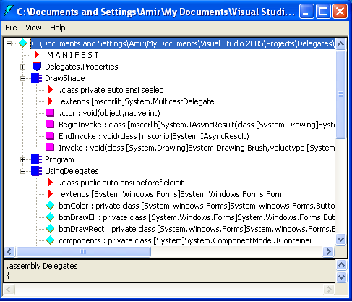
There's a great deal of information here, as you might expect in a Windows application. The important part as far as we are concerned is the MSIL code for DrawShape. Note the following points about DrawShape:
- DrawShape is a class. Whenever we define a new delegate type in our application, the compiler generates a class to encapsulate the information in the delegate's signature.
- The MSIL syntax extends [mscorlib] Systern.MulticastDelegate indicates that the generated class DrawShape inherits from a standard .NET Framework class named MulticastDelegate. MulticastDelegate is logically located in the Systerm namespace, and is physically located in the mscorlib assembly.
- DrawShape defines several methods in addition to those inherited from its super-class MulticastDelegate. First, it has methods named Beginlnvoke () and Endlnvoke ( ), which enable us to invoke methods asynchronously via the delegate, if required. In other words, we can use a delegate to invoke a method in a background thread; the main thread in the application can continue execution, without having to wait for the method to complete (asynchronous delegates).
- DrawShape has another method named Invoke (), which enables us to invoke methods synchronously via the delegate. The compiler generated the Invoke () method from the signature we specified when we defined the DrawShape type. When we call the delegate, the compiler really generates II code that calls the Invoke () method on our delegate instance. If you try to call the Invoke () method from your code, you'll see that the C# compiler raises an error, stating ' Invoke () cannot be called directly on a delegate'. In many other .NET languages, programmers have to call the Invoke () method themselves.

